**Price Data**

Original Dataset (Local only, Haiti removed)

Data Points: 263452

Date range: 2002-01-31 - 2017-12-31

Data Points for 3 Commodities in 3 Countries (Sorghum, Millet, Maize. Chad, Mauritania, Nigeria) : 62,461

Note: These are the *deflated* prices (def_value)

|  |  |  |  |  |  |  |
| --- | --- | --- | --- | --- | --- | --- |
| **Country** | **Type** | **Min Price** | **Max Price** | **Mean Price** | **Min Date** | **Max Date** |
| Chad | Maize | 69.78 | 344.70 | 185.98 | 2002-01-31 | 2017-12-31 |
| Chad | Sorghum | 62.49 | 280.00 | 140.92 | 2002-01-31 | 2017-12-31 |
| Chad | Millet | 88.02 | 383.48 | 197.99 | 2002-01-31 | 2017-12-31 |
| Mauritania | Maize | 4.889 | 20.052 | 10.896 | 2003-10-31 | 2017-12-27 |
| Mauritania | Sorghum | 3.126 | 106.505 | 12.874 | 2002-01-31 | 2017-12-27 |
| Mauritania | Millet | 4.699 | 26.118 | 11.140 | 2009-03-31 | 2017-12-27 |
| Nigeria | Maize | 18.18 | 579.96 | 62.67 | 2003-10-29 | 2017-12-27 |
| Nigeria | Sorghum | 5.89 | 273.07 | 66.77 | 2004-10-27 | 2017-12-27 |
| Nigeria | Millet | 16.73 | 180.71 | 68.66 | 2004-10-27 | 2017-12-27 |

Super High Prices (seen in the next plot)

Mauritania Sorghum: One entry is an order of 10 above the prices around it but is preceded with a period of NA. Seems like it could easily be a typo (220, where the year before the values were in the 20s).

Nigeria Sorghum: The skew is because of the high quantity of small values as opposed to one single high value (there multiple entries > 200). Seems okay.

Nigeria Maize: One market for about a month (Octoberish 2012) had prices near 600. Multiple entries of the same value make me believe that this might be real

Distributions:

See next page

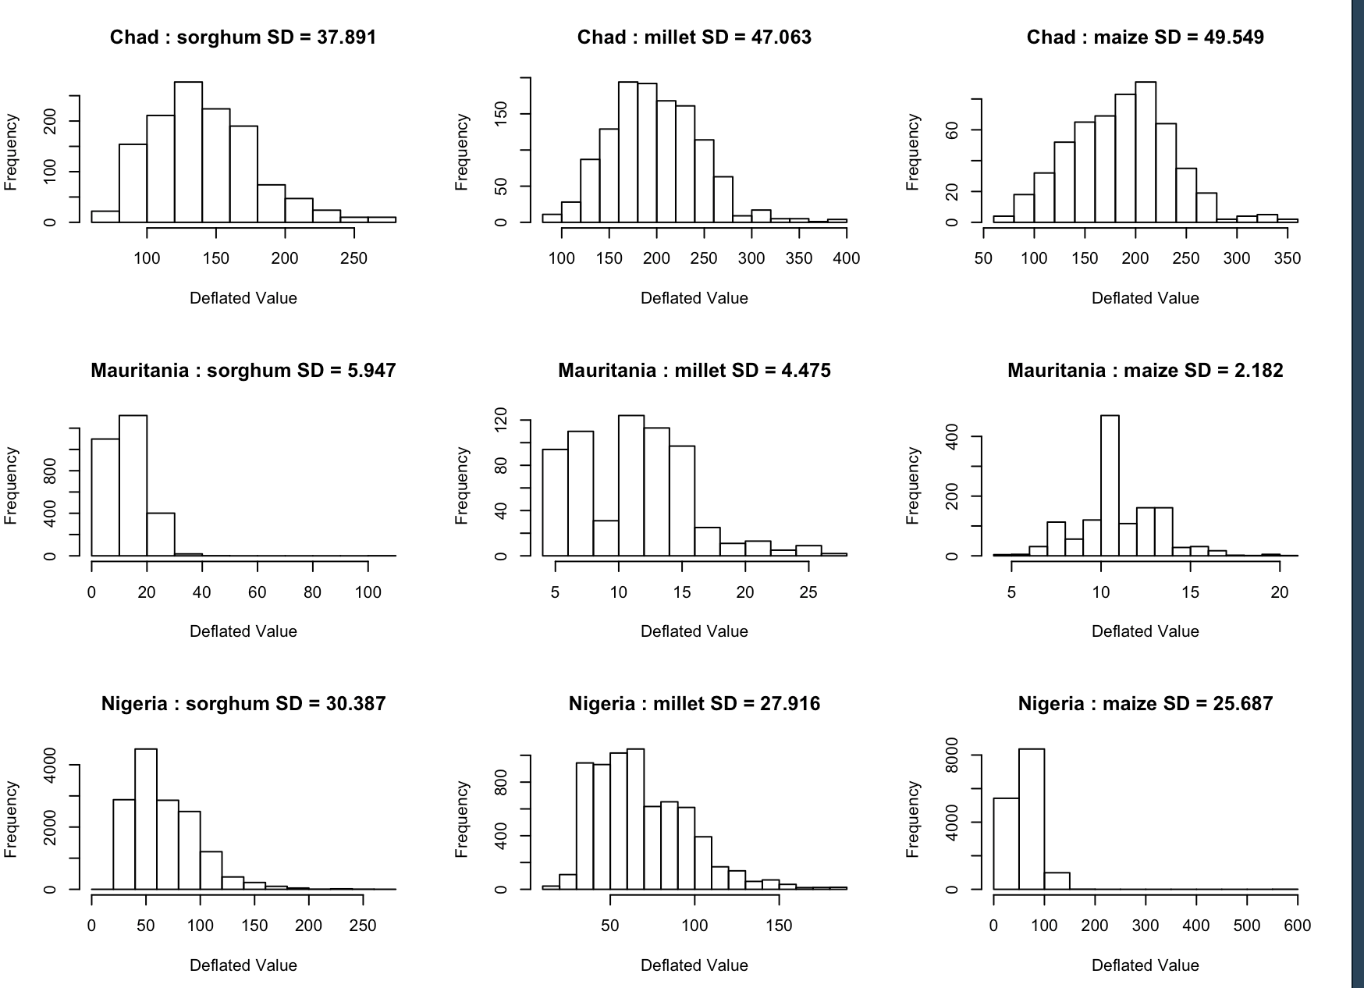

FEWS Reporting Bias:

Are the countries that only grow one type of commodity actually not growing the other three?

Djibouti only shows sorghum data in FEWS dataset, and FAO does not show either maize or millet data for this country.

Angola & Malawi show Maize data in FEWS set, but no Sorghum or Millet. FAO numbers for 2017 state that they do produce the other two crops in smaller quantities:

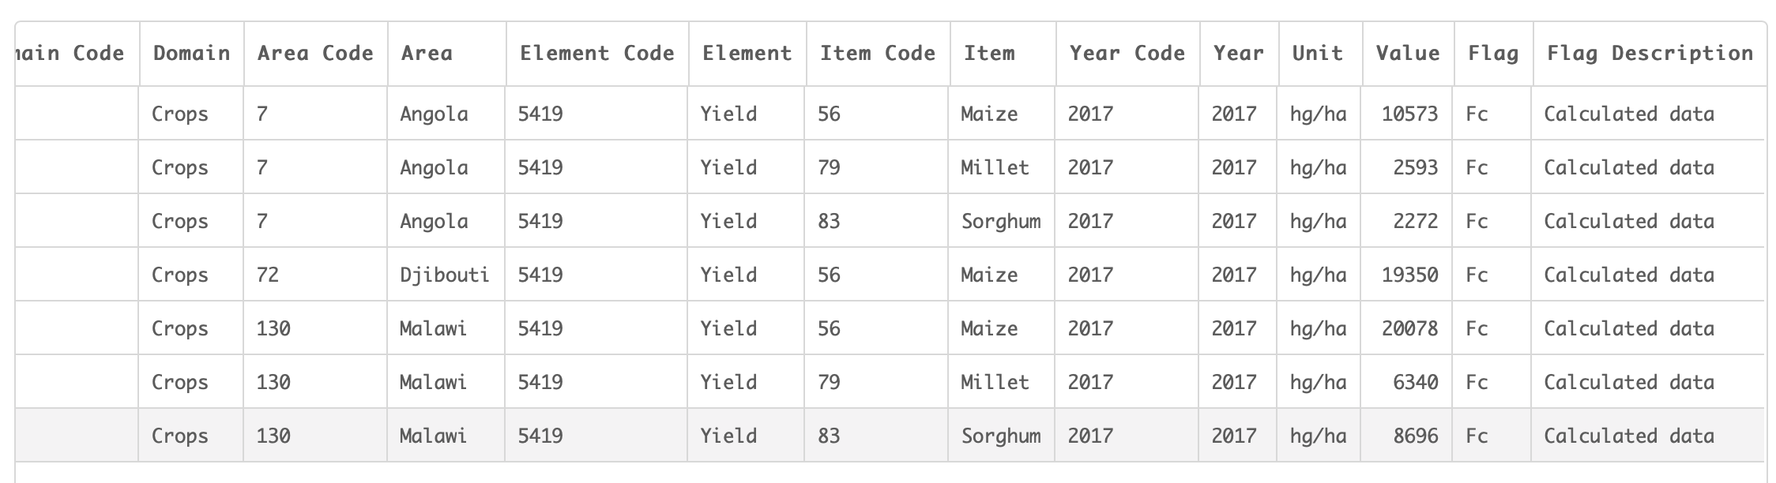

Commodity price responses



 